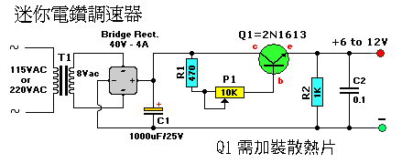
T1 = 115/8 VAC transformer. Center Tap not needed.
Q1 = 2N1613, NTE128, or substitute. (TO-39 case) On coolrib!
BR1 = 40V, 4A. (Check max current of your mini-drill and add 2A)
R1 = 470 ohm, 5%
R2 = 1K, 5%
P1 = Potentiometer, 10K
C1 = 1000uF, 40V
C2 = 0.1uF, ceramic

